First, we conduct the PCA.

burial.KWL= read.delim("burials_Kiwulan.csv", header=T, sep=",")

u.burial.KWL= read.delim("upperburials_Kiwulan.csv", header=T, sep=",")

l.burial.KWL= read.delim("Lowerburials_Kiwulan.csv", header=T, sep=",")

u.burial.KWL= read.delim("upperburials_Kiwulan.csv", header=T, sep=",")

u.burials= na.omit(u.burial.KWL[13:29])

par(las=2,mar=c(6,4,4,2))

boxplot(u.burials, main= " burial goods", xlab=" Elements")

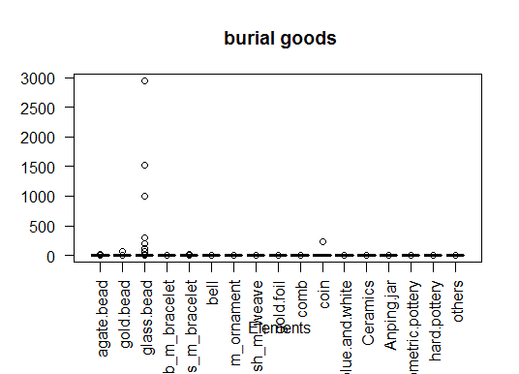

Because there are different degrees of magnitude, I standardized the elements by subtracting the mean and dividing by the standard deviation for each element.

mean.elements= sapply(u.burials, mean)

sd.elements= sapply(u.burials, sd)

burials.z = t( (t(u.burials)- mean.elements)/sd.elements)

par(las=2,mar=c(6,4,4,2))

boxplot(burials.z, main="burial goods", xlab="Standarized Elements")

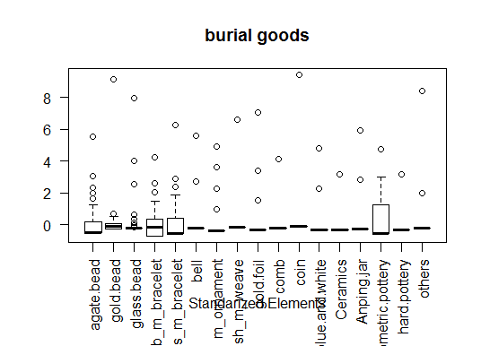

Then, calculate the correlation matrix

options('digits')

options(digits= 3)

R= cor(burials.z, use="complete.obs")

R

agate.bead gold.bead glass.bead b_m_bracelet

agate.bead 1.00000 -0.0913 0.19298 0.24441

gold.bead -0.09129 1.0000 0.26966 -0.01806

glass.bead 0.19298 0.2697 1.00000 0.15773

b_m_bracelet 0.24441 -0.0181 0.15773 1.00000

s_m_bracelet 0.37369 -0.0481 0.55630 0.38945

bell -0.03426 -0.0320 -0.00821 -0.05875

m_ornament 0.02121 -0.0219 0.47589 0.02975

fish_m_weave -0.07623 0.0775 -0.02542 0.09830

gold.foil -0.15531 0.2744 0.08730 0.08124

comb 0.18779 -0.0285 0.38808 0.14471

coin 0.24790 -0.0125 0.84441 0.15714

blue.and.white 0.00361 -0.0369 0.41047 0.00719

Ceramics 0.00864 -0.0306 -0.03834 0.29012

Anping.jar 0.13062 -0.0161 -0.02368 0.18041

geometric.pottery -0.00976 0.1979 0.03902 0.35062

hard.pottery -0.04689 -0.0244 -0.05885 0.07397

others 0.21011 -0.0302 0.74619 0.15177

s_m_bracelet bell m_ornament fish_m_weave

agate.bead 0.3737 -0.03426 0.0212 -0.0762

gold.bead -0.0481 -0.03198 -0.0219 0.0775

glass.bead 0.5563 -0.00821 0.4759 -0.0254

b_m_bracelet 0.3894 -0.05875 0.0297 0.0983

s_m_bracelet 1.0000 0.17688 0.2584 0.0271

bell 0.1769 1.00000 0.0861 -0.0344

m_ornament 0.2584 0.08608 1.0000 -0.0581

fish_m_weave 0.0271 -0.03440 -0.0581 1.0000

gold.foil -0.0301 -0.07009 -0.0365 0.7872

comb 0.3647 -0.05535 0.1655 -0.0366

coin 0.6687 -0.02419 0.5252 -0.0160

blue.and.white 0.3851 -0.07160 0.4122 -0.0473

Ceramics 0.2284 -0.07128 -0.0683 -0.0471

Anping.jar 0.2532 0.13981 -0.1067 -0.0417

geometric.pottery -0.0634 -0.06328 -0.0733 0.3192

hard.pottery -0.0970 -0.07128 -0.1205 -0.0471

others 0.5640 -0.04381 0.4707 -0.0289

gold.foil comb coin blue.and.white Ceramics

agate.bead -0.15531 0.1878 0.2479 0.00361 0.00864

gold.bead 0.27439 -0.0285 -0.0125 -0.03690 -0.03056

glass.bead 0.08730 0.3881 0.8444 0.41047 -0.03834

b_m_bracelet 0.08124 0.1447 0.1571 0.00719 0.29012

s_m_bracelet -0.03012 0.3647 0.6687 0.38507 0.22844

bell -0.07009 -0.0553 -0.0242 -0.07160 -0.07128

m_ornament -0.03645 0.1655 0.5252 0.41216 -0.06835

fish_m_weave 0.78717 -0.0366 -0.0160 -0.04730 -0.04709

gold.foil 1.00000 -0.0745 -0.0326 0.00876 -0.09594

comb -0.07449 1.0000 0.4370 0.29749 0.09469

coin -0.03256 0.4370 1.0000 0.51099 -0.03311

blue.and.white 0.00876 0.2975 0.5110 1.00000 0.00223

Ceramics -0.09594 0.0947 -0.0331 0.00223 1.00000

Anping.jar -0.02125 0.2349 -0.0293 -0.08682 -0.08642

geometric.pottery 0.37942 -0.1284 -0.0561 -0.06544 -0.02756

hard.pottery -0.02398 -0.0758 -0.0331 -0.09801 0.03963

others -0.05897 0.3725 0.8955 0.43268 0.02436

Anping.jar geometric.pottery hard.pottery others

agate.bead 0.1306 -0.00976 -0.0469 0.2101

gold.bead -0.0161 0.19791 -0.0244 -0.0302

glass.bead -0.0237 0.03902 -0.0588 0.7462

b_m_bracelet 0.1804 0.35062 0.0740 0.1518

s_m_bracelet 0.2532 -0.06345 -0.0970 0.5640

bell 0.1398 -0.06328 -0.0713 -0.0438

m_ornament -0.1067 -0.07330 -0.1205 0.4707

fish_m_weave -0.0417 0.31925 -0.0471 -0.0289

gold.foil -0.0212 0.37942 -0.0240 -0.0590

comb 0.2349 -0.12840 -0.0758 0.3725

coin -0.0293 -0.05612 -0.0331 0.8955

blue.and.white -0.0868 -0.06544 -0.0980 0.4327

Ceramics -0.0864 -0.02756 0.0396 0.0244

Anping.jar 1.0000 -0.02441 -0.0864 -0.0531

geometric.pottery -0.0244 1.00000 0.0413 0.0254

hard.pottery -0.0864 0.04134 1.0000 0.1087

others -0.0531 0.02541 0.1087 1.0000

> PCA= prcomp(burials.z)

> summary(PCA)

Importance of components:

PC1 PC2 PC3 PC4 PC5 PC6 PC7

Standard deviation 2.047 1.490 1.307 1.1596 1.0359 1.0135 1.0055

Proportion of Variance 0.246 0.131 0.101 0.0791 0.0631 0.0604 0.0595

Cumulative Proportion 0.246 0.377 0.478 0.5566 0.6197 0.6802 0.7396

PC8 PC9 PC10 PC11 PC12 PC13

Standard deviation 0.9585 0.8951 0.7647 0.7570 0.7295 0.6428

Proportion of Variance 0.0541 0.0471 0.0344 0.0337 0.0313 0.0243

Cumulative Proportion 0.7937 0.8408 0.8752 0.9089 0.9402 0.9645

PC14 PC15 PC16 PC17

Standard deviation 0.4675 0.4421 0.36508 0.23614

Proportion of Variance 0.0129 0.0115 0.00784 0.00328

Cumulative Proportion 0.9774 0.9889 0.99672 1.00000

eigenvalues= PCA$sdev^2

plot(1:length(eigenvalues), eigenvalues, main="Scree plot",

xlab="Components", ylab=" Eigenvalues",type="l", col="red")

axis(1, at= 1:length(eigenvalues))

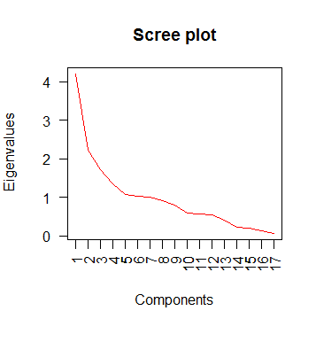

Based on the scree plot, we will consider the first five components.

> loadings= PCA$rotation^2

> loadings

PC1 PC2 PC3 PC4 PC5 PC6 PC7

agate.bead 2.74e-02 0.006821 1.30e-01 1.27e-03 3.73e-02 0.008657 0.094910

gold.bead 3.10e-05 0.074884 1.68e-02 2.21e-03 2.66e-01 0.074556 0.348402

glass.bead 1.73e-01 0.011568 1.83e-02 8.09e-06 5.49e-02 0.002177 0.016458

b_m_bracelet 1.90e-02 0.037305 2.70e-01 4.12e-02 2.98e-05 0.021260 0.007848

s_m_bracelet 1.42e-01 0.000046 8.09e-02 1.46e-02 1.16e-02 0.018041 0.006367

bell 2.95e-05 0.007843 1.75e-03 2.24e-01 2.17e-03 0.477401 0.057668

m_ornament 8.20e-02 0.000919 8.94e-02 2.27e-03 1.16e-02 0.053430 0.005249

fish_m_weave 8.03e-04 0.298026 3.62e-05 1.75e-02 1.01e-01 0.001675 0.057485

gold.foil 8.08e-04 0.354932 6.83e-03 1.67e-02 2.29e-02 0.001261 0.008448

comb 7.33e-02 0.004027 2.18e-02 1.35e-02 9.82e-03 0.186337 0.002209

coin 2.11e-01 0.000214 1.21e-02 9.95e-04 2.37e-03 0.001113 0.009285

blue.and.white 8.63e-02 0.000233 5.34e-02 8.13e-04 8.81e-02 0.009188 0.000649

Ceramics 1.26e-03 0.001358 1.06e-01 1.58e-01 1.75e-01 0.000267 0.267226

Anping.jar 1.12e-03 0.001591 1.63e-01 2.38e-01 2.84e-02 0.028654 0.005660

geometric.pottery 5.28e-04 0.199897 1.92e-02 1.91e-02 4.30e-02 0.025907 0.000375

hard.pottery 1.25e-03 0.000005 1.64e-03 2.26e-01 1.35e-01 0.079148 0.094206

others 1.79e-01 0.000330 9.24e-03 2.31e-02 1.13e-02 0.010928 0.017556

PC8 PC9 PC10 PC11 PC12 PC13 PC14

agate.bead 2.35e-01 0.19961 0.02322 6.37e-03 1.50e-01 5.46e-02 0.012068

gold.bead 2.73e-03 0.02937 0.02419 2.08e-03 4.10e-02 1.47e-03 0.089848

glass.bead 3.04e-05 0.01004 0.01121 1.82e-03 2.54e-02 8.31e-03 0.268748

b_m_bracelet 1.89e-02 0.09972 0.00144 2.56e-02 2.32e-02 3.75e-01 0.002254

s_m_bracelet 2.97e-03 0.03029 0.08712 3.59e-03 3.64e-02 7.18e-03 0.128196

bell 2.18e-02 0.02071 0.00344 1.20e-01 1.98e-02 1.14e-03 0.011451

m_ornament 3.20e-02 0.06846 0.06336 2.24e-01 2.76e-01 5.29e-02 0.013898

fish_m_weave 1.27e-02 0.06350 0.00493 4.07e-03 2.10e-03 8.36e-05 0.160007

gold.foil 2.00e-02 0.02012 0.00509 1.19e-02 8.69e-03 5.54e-06 0.242956

comb 1.18e-01 0.00607 0.21833 2.03e-01 1.13e-01 5.11e-03 0.004212

coin 5.30e-05 0.00562 0.00505 5.87e-04 5.86e-02 1.73e-03 0.000507

blue.and.white 1.58e-03 0.09221 0.47709 8.95e-02 4.74e-02 3.43e-04 0.003993

Ceramics 2.16e-02 0.04326 0.00453 3.85e-03 8.61e-05 1.73e-01 0.023681

Anping.jar 9.42e-02 0.11611 0.01917 1.24e-01 1.31e-02 1.23e-01 0.006770

geometric.pottery8.19e-02 0.19156 0.00931 1.77e-01 1.70e-02 1.65e-01 0.005026

hard.pottery 3.32e-01 0.00159 0.02347 1.25e-03 7.63e-02 5.10e-03 0.000003

others 4.52e-03 0.00176 0.01905 2.07e-05 9.16e-02 2.63e-02 0.026381

PC15 PC16 PC17

agate.bead 0.01222 4.94e-05 1.46e-04

gold.bead 0.01741 5.54e-03 3.60e-03

glass.bead 0.02070 2.87e-01 9.00e-02

b_m_bracelet 0.05723 5.19e-04 3.56e-07

s_m_bracelet 0.38556 2.02e-02 2.50e-02

bell 0.02873 4.64e-05 1.35e-03

m_ornament 0.02293 7.52e-04 5.90e-04

fish_m_weave 0.04839 2.25e-01 3.37e-03

gold.foil 0.01648 2.60e-01 2.40e-03

comb 0.01391 5.97e-03 6.16e-04

coin 0.00615 1.91e-04 6.84e-01

blue.and.white 0.03961 8.67e-03 8.56e-04

Ceramics 0.01107 3.53e-03 5.91e-03

Anping.jar 0.02679 8.15e-03 1.73e-03

geometric.pottery 0.04091 2.15e-03 2.16e-03

hard.pottery 0.01492 7.48e-03 1.30e-03

others 0.23699 1.65e-01 1.77e-01

Based on the above results, the table as following shows that two of the original variables are best explained by PC1 to PC5

|  |  |  |  |  |
| --- | --- | --- | --- | --- |
| PC1 | PC2 | PC3 | PC4 | PC5 |
| Coin (21.1%) | Gold foil(35.5%) | Big metal bracelet(27%) | An-ping jar(23.8%) | Gold bead (26.6%) |
| others(17.9%) | Metal weave fish-shape(29.8%) | An-ping jar(16.3%) | Hard pottery(22.6%) | Ceramics (17.5%) |

Generate the byplots of the burials good by using all of the principle components. First, I use gender labels the elements.

plot(PCA$x[,1], PCA$x[,2], pch=".",xlab="PC1", ylab="PC2", main="Pottery - PC1 .vs. PC2")

labels= factor(gender)

text(PCA$x[,1], PCA$x[,2], labels, cex=0.7)

abline(h=0, v=0, lty=2, col="red")

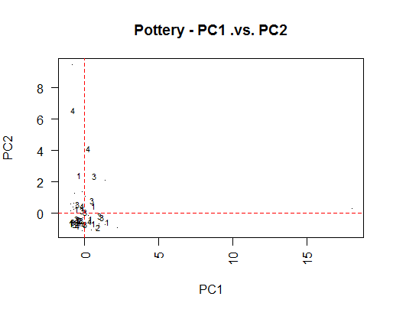

From above plot, there is no obvious group (1 refers to male, 2 refers to possible male; 3 refers to female, 4 refers to possible female).

If we use label of age, the results as following.

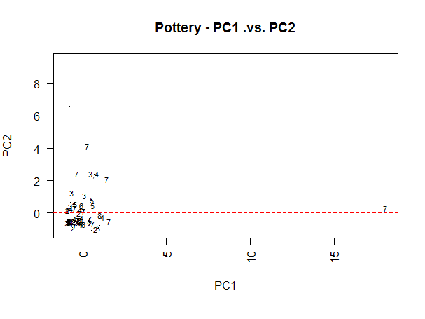

|  |  |
| --- | --- |
| number | Age |
| 1 | 0-3 |
| 2 | 3-12 |
| 3 | 12-20 |
| 4 | 20-35 |
| 5 | 35-50 |
| 6 | >50 |
| 7 | >18 |
| 8 | Unknown |

The plot shows there is no obvious group based on age.

